Housemate Helper

OVO

Completion: 11/30/21

Revision 1: 11/17/21

Sprint 4 Plan

Sprint Goal:

Complete all the finishing touches and final details of the application.

Task Listing:

* User Story 1: As a housemate, I want to be able to split the expenses so that all the housemates can contribute to the costs of living in the house.
  + Split expense by number of people in the group (1 hour)

Team Roles:

* Matthew Atmadja: Product Owner, Developer
* Rishab Aida: Scrum Master, Developer
* Ashvini Bhupatiraju: Developer
* Vinay Prasad: Developer
* Sukhveer Karlcut: Developer
* Rishika Patel: Developer

Initial Tasks Assignments:

* Finishing Touches
  + All team members
* Split expenses
  + Suki, Rishab

Initial Burnup Chart:

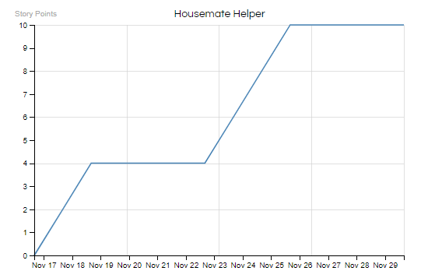

Initial Scrum Board:

| Stories | To Do | In Progress | Done |
| --- | --- | --- | --- |
| User Story 1 | * Calculate Expenses to be split * Display split expenses |  |  |

Scrum Times:

* Team meets every Tuesday, Thursday, Saturday